**[What Does the RAM Slot Color Coding on Motherboards Mean?](http://www.howtogeek.com/174482/what-does-the-ram-slot-color-coding-on-motherboards-mean/" \o "What Does the RAM Slot Color Coding on Motherboards Mean?)**

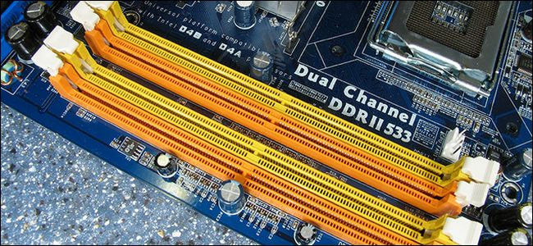

Yellow and orange, blue and black, green and red: you’ll find the RAM slots on motherboards in all sorts of  color pairs. But what exactly do those pairs mean and how does it affect you when system building or upgrading your current rig?

*Today’s Question & Answer session comes to us courtesy of SuperUser—a subdivision of Stack Exchange, a community-driven grouping of Q&A web sites. Image courtesy of question asker, Totymedli.*

The Question

SuperUser reader Totymedli is curious about the color coding of RAM slots:

I have always seen that the motherboard RAM slots are colored in pairs, but never knew what it meant. I just put the 2 RAM in, and after a few tries it always worked. But after I tried to install a third one it always throws me a blue screen of death. Is there an order how should I install RAM to the board? What do the colors mean? Do they indicate a performance boost opportunity or are they just a guide for installation?

What’s the solution for his blue screen installation issues?

The Answer

SuperUser contributor Enigma breaks the code:

It means that the colored pair is a dual channel set and that you should install RAM as a pair to take advantage of it.

You should install 2 of the same sticks as a matching pair on the same color slots and then another 2 that are the same in the remaining two slots.

Ideally you want to have all memory be identical in a system or else you will end up with some memory being potentially downclocked (or voltage/multiplier) to the lowest common denominator.

Further reading:

[Tom’s Hardware Forum: How to Install Dual Channel [Memory]?](http://www.tomshardware.com/forum/254308-30-install-dual-channel)

[Hardware Secrets: Everything You Need to Know About Dual-, Triple-, and Quad-Channel Memory Architectures](http://www.hardwaresecrets.com/article/Everything-You-Need-to-Know-About-the-Dual-Triple-and-Quad-Channel-Memory-Architectures/133/5)

Unfortunately the color pairing scheme isn’t standardized on older motherboards (more recent boards seem to consistently obey the color-indicates-memory-channel-rule, though).

In light of that, Ecnerwal’s advice on the importance of checking the manual carefully should not be ignored:

The colors are nicely answered by Enigma. As for:

*But after I tried to install a third one it always throws me a blue screen of death. Is there an order how should I install RAM to the board?*

The answer is **Yes, there is an order**, and the details are found in your motherboard manual, which nearly always has detailed instructions for what order the memory slots should be filled, and which configurations will work, so you can simply put it in once and have it work, rather than:

*I just put the 2 RAM in, and after a few tries it always worked.*

As in all things related to electronics and computer building, reading the manual first and avoiding blue screens of death (or, worse, damaging hardware) is always preferred to trial-and-error. When in doubt, reference the manual.